# How to create a SQL Server database backup:

**1. Typical FULL backup**

Open SSMS, connect to database instance

In Object Explorer, right click on your database > Click "Tasks" > Click "Back Up..."

In Back Up Database dialog:

Under "Backup type" click the dropdown and select "Full"

Under "Destination", click "Add" button and choose backup file path/name

Check "Back up to the existing media set"

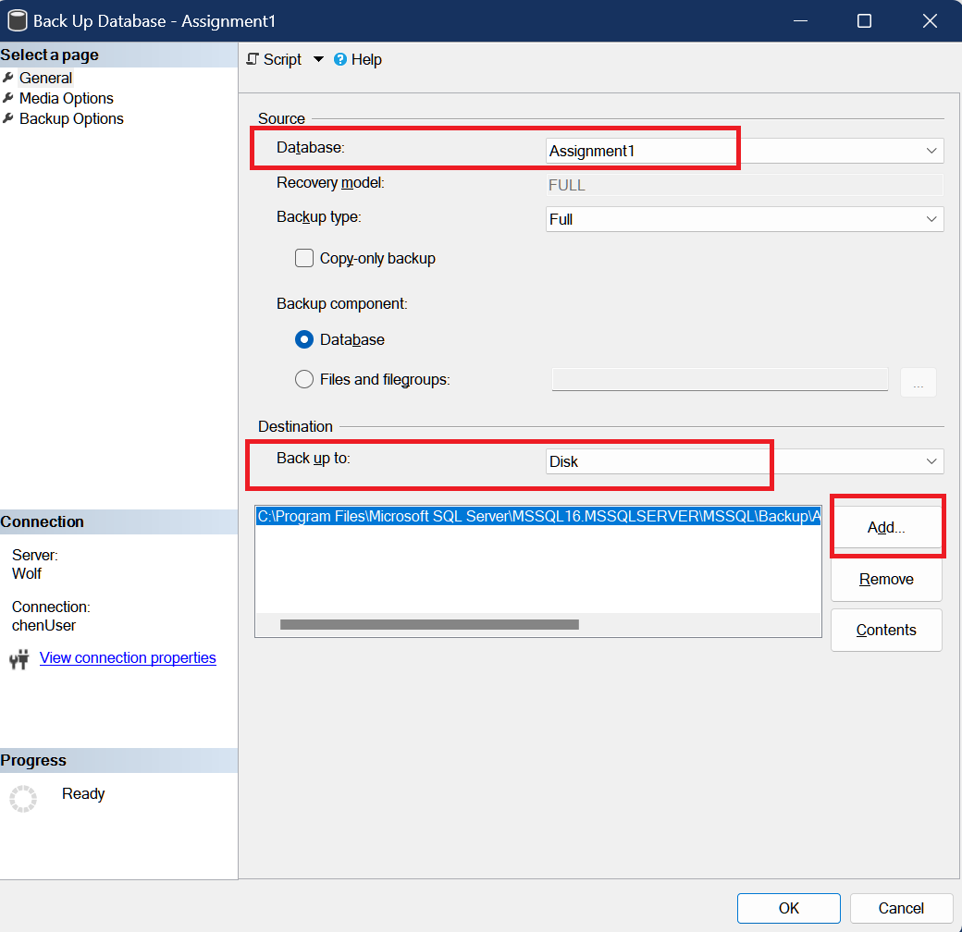

Review other options

Click "OK" button to start backup

Congratulations! Now you are all set.

**2. Advanced schedule backup**

Enter in “Backup Test”, and click the Schedule Calendar, pop up next menu that can setting like this:

Go to SQL Server Agent – BACKUP_TEST_Subplan_1, right click “start job at Step…”

Open the backup directory and double check the .bak file for each day.

How to backup Access database

**1. Basic backup**

Save as the database by select “Back up Database”

**2. Advance backup via Windows image**

1) search “file history” to open file history APP

2) Connect the secondary disk, turn on the “Removable Disk (D)”

3) click “System Image Backup”, enter “backup setting”

4) Setting by steps

5)

Select the backup folder created previously.

check the backup schedule.

save setting.

6) return backup menu and click “backup now”

7) When complete, double check on “removeable disk which find the image backup has existed.

